Name Roll#
Bilal L18-1350

Online Voting and Management System
Project Analysis Document

Version 1.0

Table of Contents
1. Introduction 3
1.1. Purpose 3
1.2. Project Overview 3
2. Assumptions 3
3. EER Diagram 5
4. Functionality Points 6
4.1. Functionality 1 6
4.2. Functionality 2 6
4.3. Functionality 3 6
4.4. Functionality 4 6
4.5. Functionality 5 6
4.6. Functionality 6 6
4.7. Functionality 7 6
4.8. Functionality 8 6
5. Prototype using GUIs 6
6. References 7

Introduction

The main purpose of this project is to make the Online Voting System. That system is very helpful to the people, they don’t have to go to the station. They can cast their vote from home. Our system is designed in such a way that if the user is want to cast the vote in both MNA seat or MPA seat then he/she can do that. If user want to cast in one seat either MNA or MPA he can do that. Our project can access the Nadra Database to check if the user is registered and of age then he/she can cast vote otherwise our system doesn’t allow the user to cast the vote. Our System provide user to view the profile of the candidate and the result of the area as well as the overall result of the Country.

Purpose

The purpose of our project is to introduce such an online system which can provide users with the facility of online voting or E-voting.

Project Overview
In online voting a voter or a user can use his/her voting right without any difficulty. He or she first has to get them self registered by database. Registration is mainly done by the system administrator in which we have a devised system for online registration, where a user can register his or herself which has been further connect to NADRA database for verification. The users seeking to cast their vote mainly fill he registration form provided by system administrator and then further it would get verified as the verification is confirmed, the user would be provided by a unique voting id and he/she would become a voter. Further at the time of any elections, like general elections, local body elections, etc, they can easily cast their vote. For security reasons at the time of registration the user would be asked by the secret security question which would be of the user’s own choice, by applying this every time when the user enters the system he/she has to enter the required answers to the provided question hence increasing the flexibility at the security point of view. Further as the entered the system they can cast their vote easily

Assumptions
- The user can cast two votes
One for National Assembly
And other for Provincial Assembly
- A user can be Candidate or can be a voter.
- The candidate can also cast vote
- The administrator is also a user.
- The administrator is verified the user that they are registered in Nadra.
- He also verified the registered user can cast vote or not.
- Every user must pass the multiple security to cast the vote which include password, or question
- We assume that the user must give the password as well the security question at the time of the registration in Nadra.
- The administrator can also update the data in the already existing system. He can add or delete the information of the user.
- The MNA is identify with the National Assembly no.
- The MPA is identify with the National Assembly no with Union Council no.
- The area result have final result of both MNA and MPA

EER Diagram
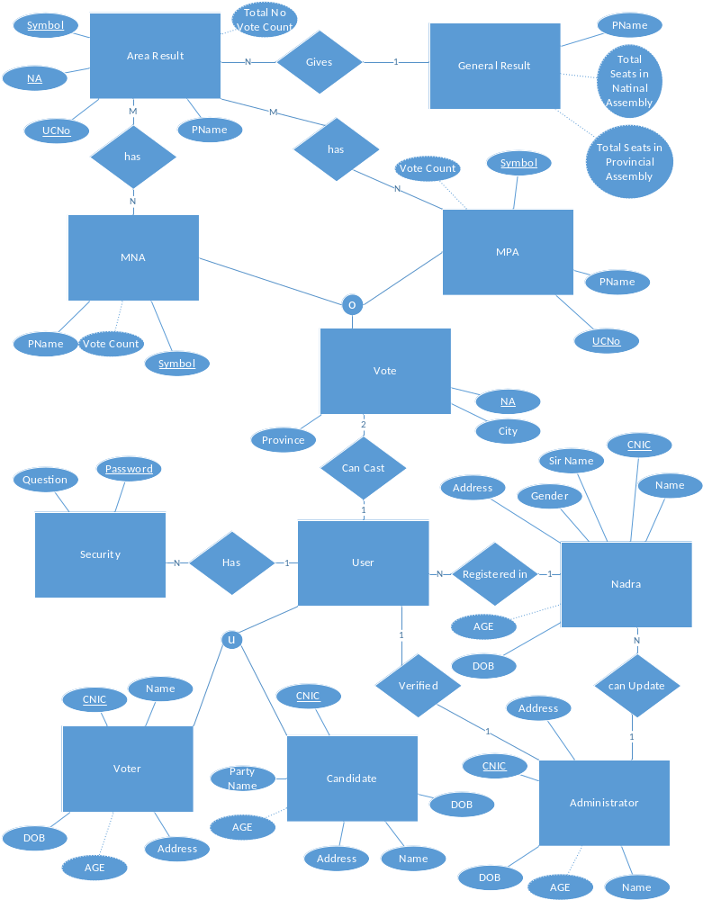

Functionality Points

Functionality 1
User can login to the system as candidate or as voter

Functionality 2
User can cast vote through this system.

Functionality 3
Users can see the result of their respective areas as well as the general result in there

Functionality 4
User as administrator can update the data of other users

Functionality 5
User can also see the profile of the Candidate.

Functionality 6
User as who is registered in Nadra and are under age cannot cast vote

Functionality 7
User can cast in only one provincial seat and only one National Assembly seat

Functionality 8
User can also vote for one seat either Provincial or National Assembly Seats. But one user cannot more than two votes.

Prototype using GUIs
On the user interface side the GUI would consist of webpage’s wit would be connected to the serve to access the defined DBMS. The first page would consist of user login and id if they have been registered to the system. Further there would be a registration page with empty fields I which the users have to enter his/her required information to register to the system. Further on to cast their vote there would be system which would generate a e ballot paper consisting of all the contesting candidates an user can easily cast their vote to the desired candidate on an of the contesting seats respectively.
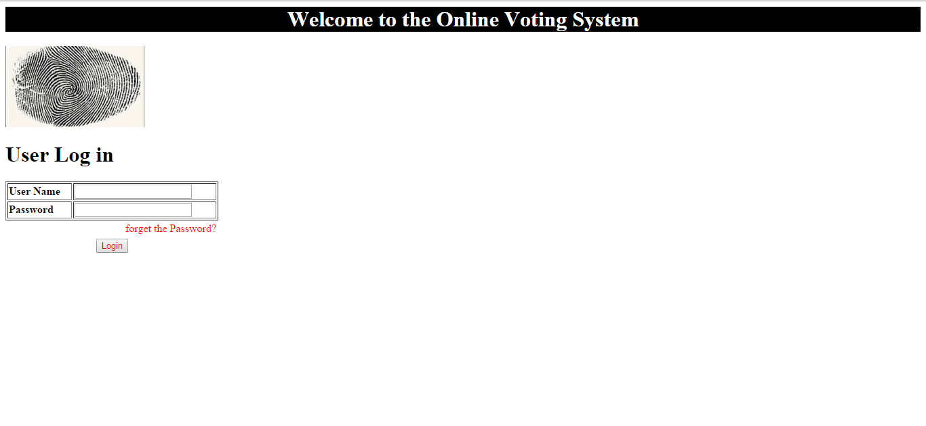

References
1. http://www.slideshare.net/nitinbhasin3/online-voting-system-project-file
2. http://www.slideshare.net/karthikrkaranth/online-voting-system-new?related=3
3. http://www.slideshare.net/wilsonnandasaba/project-reportonline-voting-system
4. Ramez Elmasri, Shamkant B. Navathe Fundamentals of Data Base Systems 6th ed.

